Practical – 05
Class: - B.E.E&TC Subject: - VLSI Design and Technology
Aim: - To implement an inverter (not gate), NAND, NOR gate & 1 Bit Half Adder using CMOS technology
Theory :-
A] CMOS Inverter:
A logic inverter can be constructed by using one P-MOS and N-MOS inverter when there is ‘0’ at input , then output is ‘1’ and vice versa. In general a fully complementary always ha san n-Switch in pull down at output.
Truth table of Inverter:-
INPUT | OUTPUT
0 | 1
1 | 0
This is truth table of logic inverter where when there is a ‘0’ at the input the output is ‘1’ and when there is ‘1’ at the input one output will zero.
Schematic of CMOS Inverter
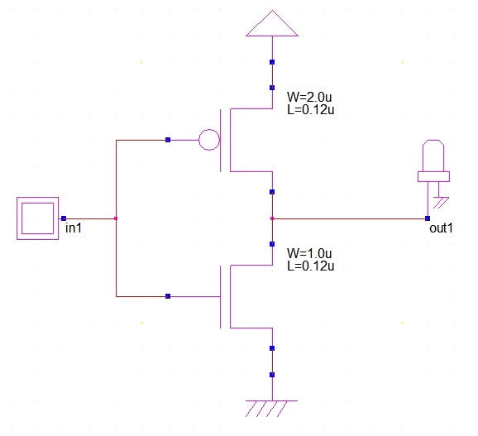
Part A: Wp=Wn=1 µm , Ln=Lp=0.2 µm
Design Layout & Timing Diagram of CMOS Inverter
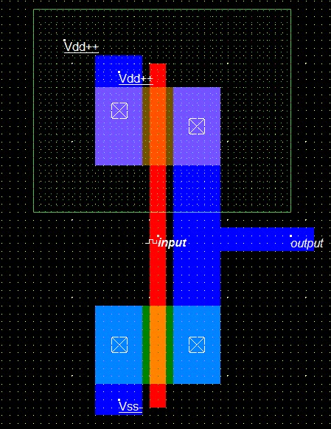
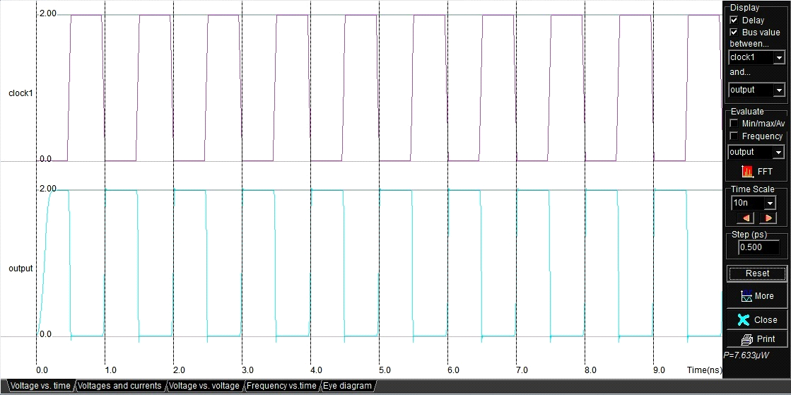
Part B: Wp=2.5Wn (Wn=1 µm) , Ln=Lp=0.2 µm
Design Layout & Timing Diagram of CMOS Inverter
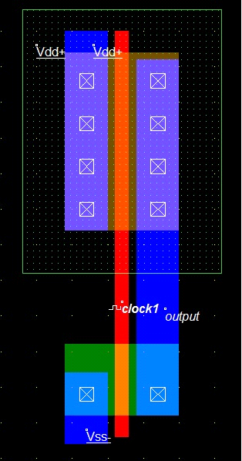
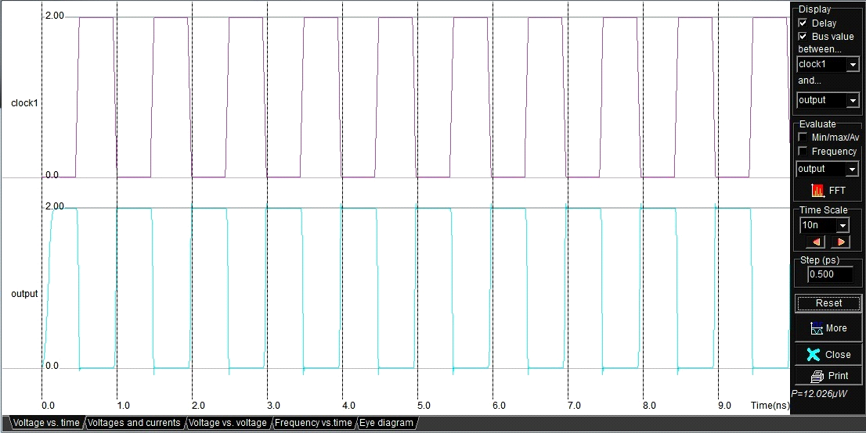

Part C: Wp=5Wn (Wn=1 µm) , Ln=Lp=0.2 µm
Design Layout & Timing Diagram of CMOS Inverter
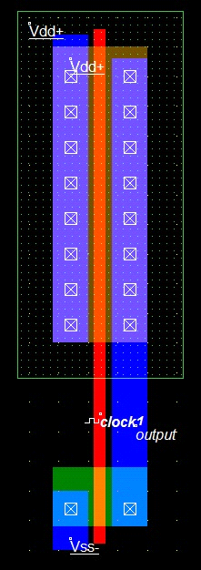
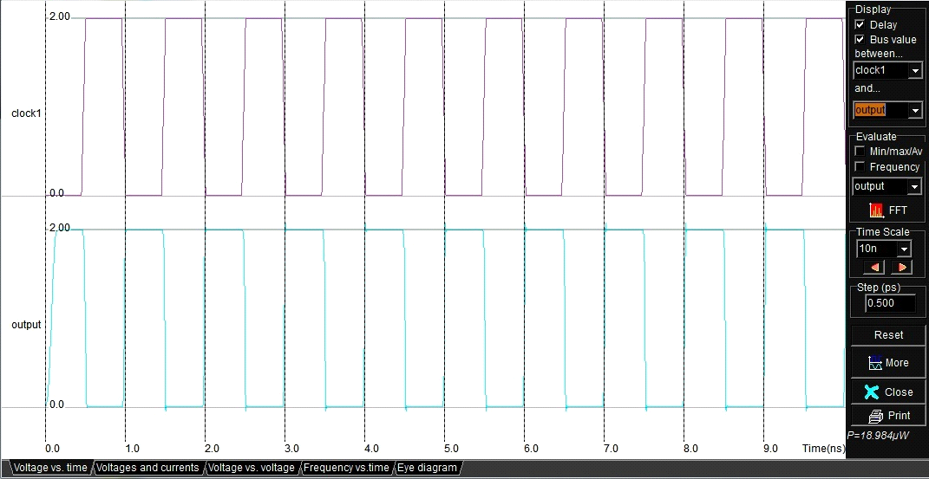
Observation Table:
- Effect of Change in Width on different parameters ( Without Capacitor)
Sr No | Width | Power Dissipation | Rise Time Tr | Fall Time Tf
1
2
3

- Effect of Change in Width on different parameters ( With Capacitor=0.01pF)
Sr No | Width | Power Dissipation | Rise Time Tr | Fall Time Tf
1
2
3

Conclusion: -

B] CMOS NAND Gate
Theory :- NAND Gate is formed by connecting an inverter i.e. NOT gate at the output of an AND gate
Truth Table:-
Input |  | Outputs
A | B | C
0 | 0 | 1
0 | 1 | 1
1 | 0 | 1
1 | 1 | 0

Schematic of CMOS NAND Gate:
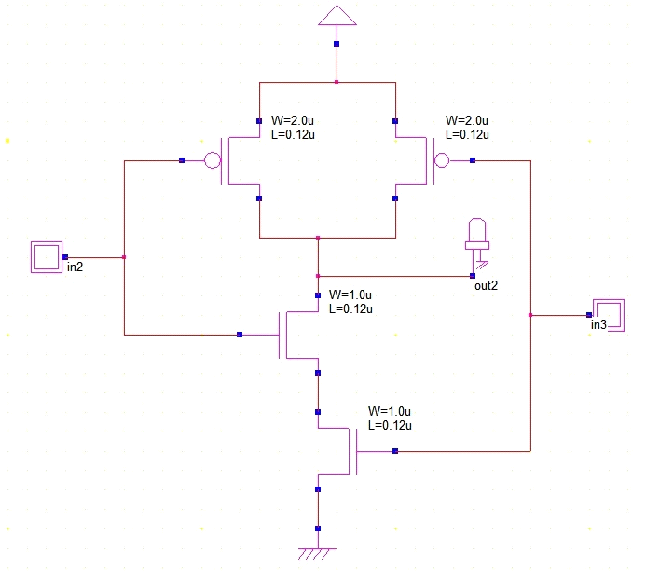

Part A: Design Layout & Timing Diagram of CMOS NAND Gate without capacitor
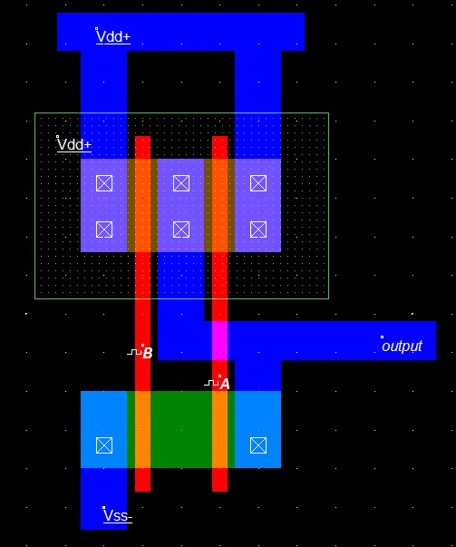
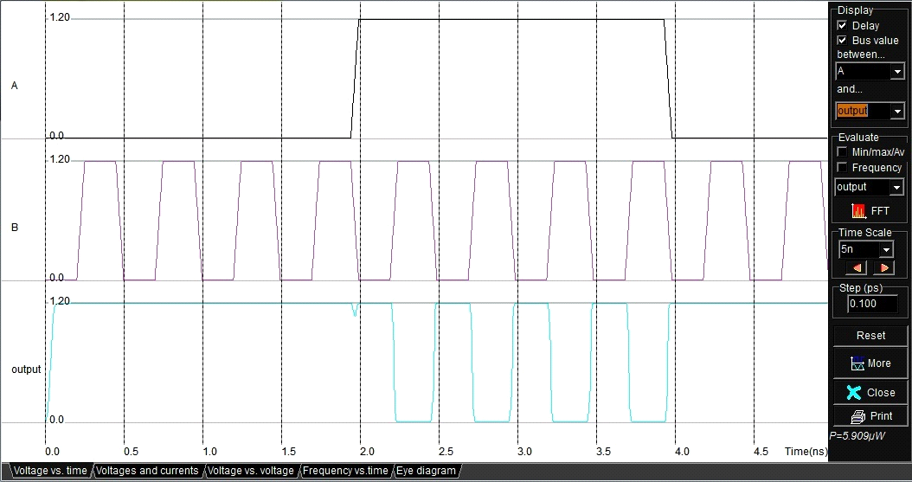
Part B: Design Layout & Timing Diagram of CMOS NAND Gate
with capacitor
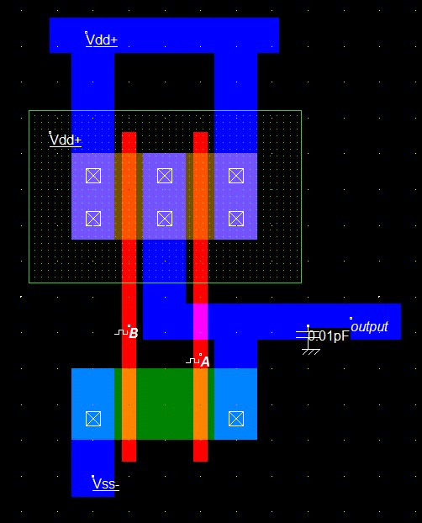
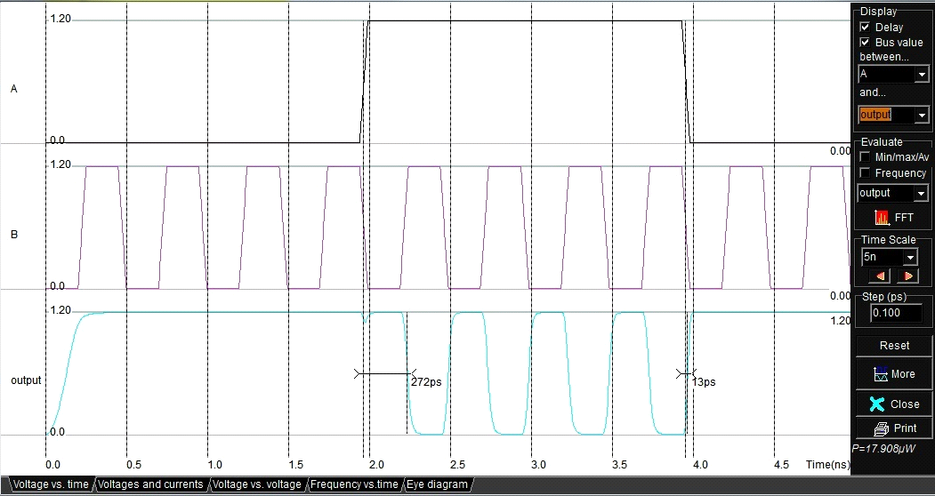

Observation Table:
- Effect of Capacitor on Power Dissipation
Sr No | Capacitor | Power Dissipation
1 | Without Capacitor
2 | With Capacitor (0.01pF)

Conclusion: -

C] CMOS NOR Gate:
Theory :- A 2 input NOR gate can be constructed using NMOS & PMOS .
Truth Table:-
Input |  | Outputs
A | B | C
0 | 0 | 1
0 | 1 | 0
1 | 0 | 0
1 | 1 | 0

Schematic of CMOS NOR Gate:
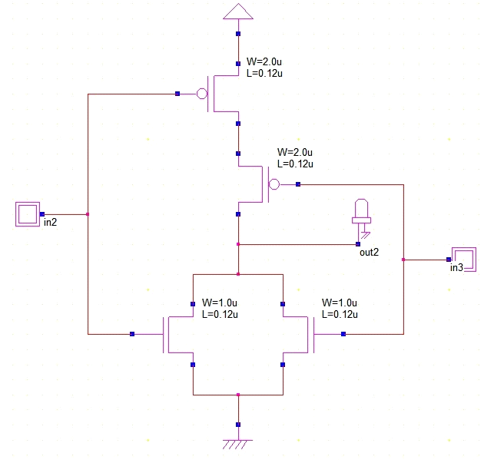
Part A: Design Layout & Timing Diagram of CMOS NOR Gate without capacitor
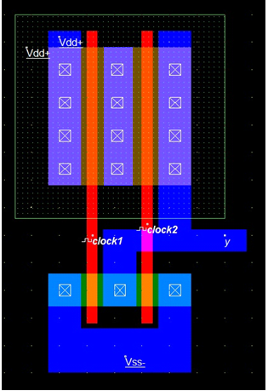
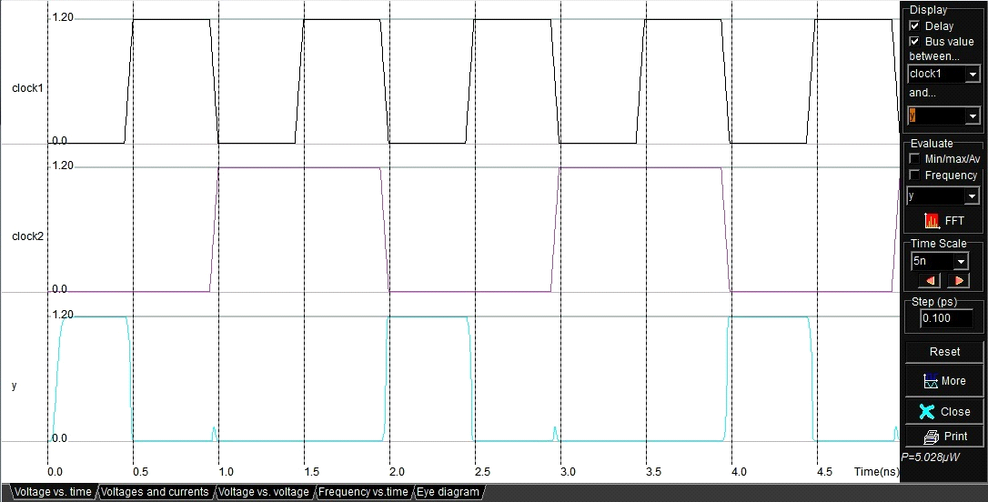
Part B: Design Layout & Timing Diagram of CMOS NOR Gate
with capacitor
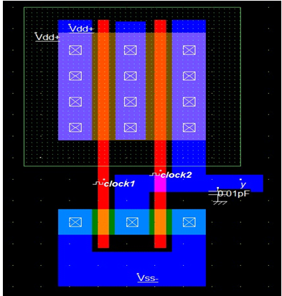
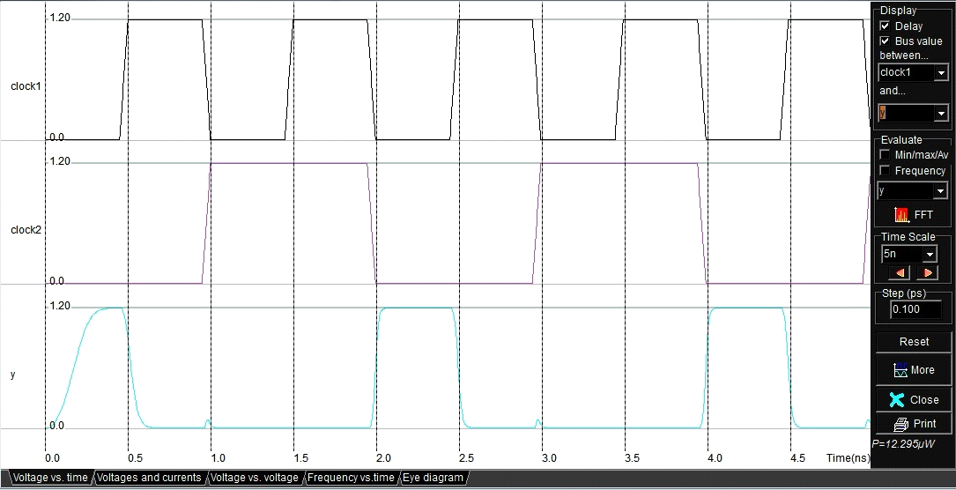

Observation Table:
- Effect of Capacitor on Power Dissipation

Sr No | Capacitor | Power Dissipation
1 | Without Capacitor
2 | With Capacitor (0.01pF)

Conclusion: -

D] CMOS HALF ADDER:
Theory: Half Adder if formed with the help of five CMOS NAND Gates.

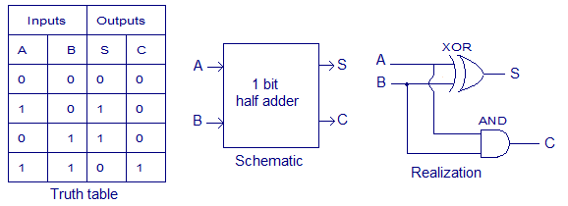
Schematic :
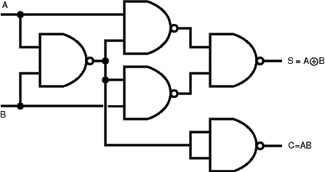

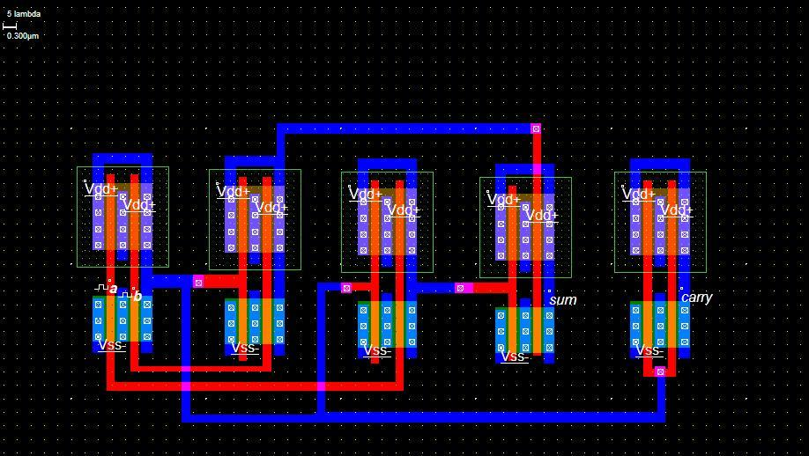

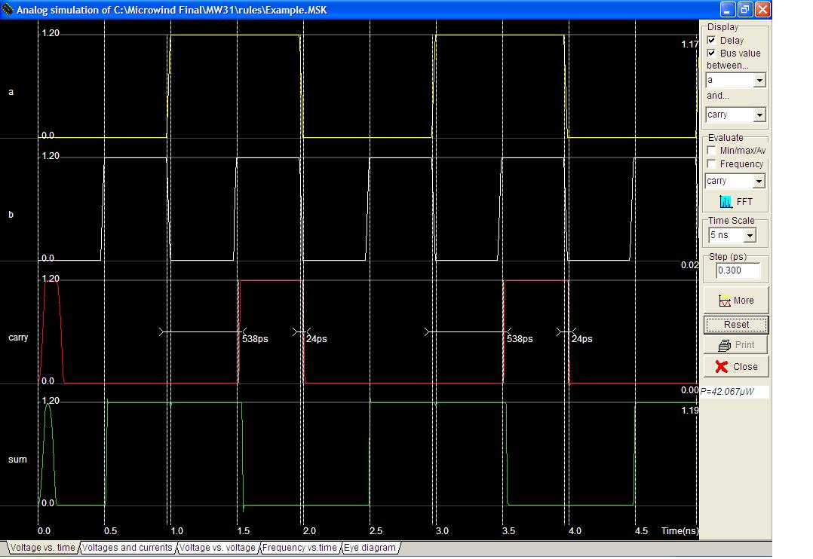
Practical - 06

Class: - B.E.E&TC Subject: - VLSI Design and Technology
Aim: - To design and implement CMOS 2:1 multiplexer using Transmission gate & also comment on no. of pass transistors required to implement the same.
Theory: -
Transmission Gates
- Pass transistors produce degraded outputs
- Transmission gates pass both 0 and 1 well

Multiplexers Using Transmission Gate
- 2:1 multiplexer chooses between two inputs
S | D1 | D0 | Y
0 | X | 0 | 0
0 | X | 1 | 1
1 | 0 | X | 0
1 | 1 | X | 1

Gate-Level Mux Design:

Transmission Gate Mux:

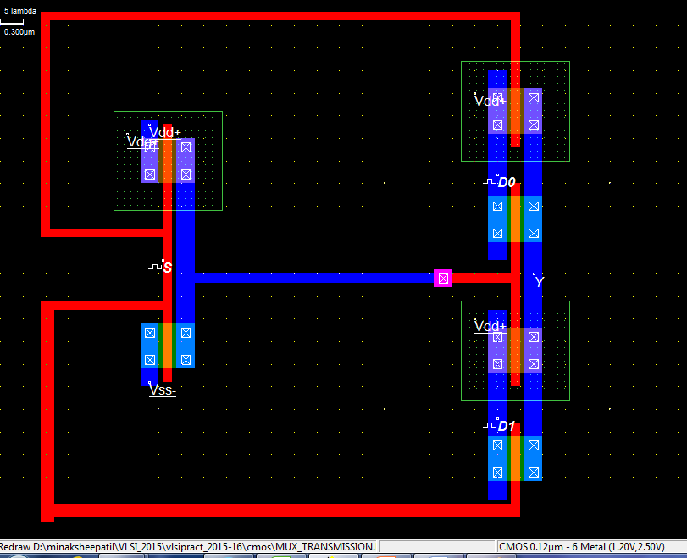

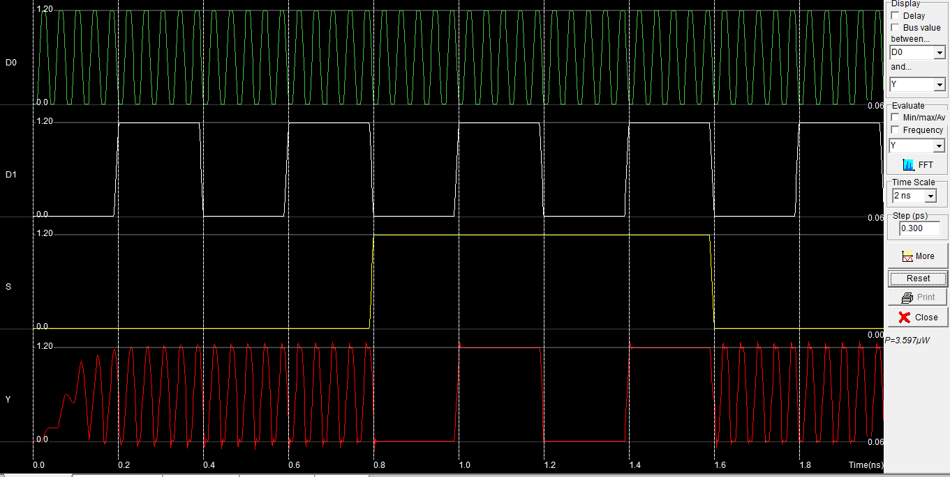

Practical - 07

Class: - B.E.E&TC Subject: - VLSI Design and Technology

Aim: Design of CMOS single bit SRAM cell layout and verify the functionality by simulation

Procedure:
Prepare the CMOS layout of single bit SRAM cell. Do the functional simulation and verify the results.
Comment on the effect of no load and capacitive load on rise time and fall time.

Circuit Diagram:

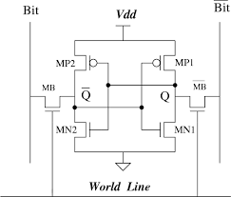

Layout Diagram:
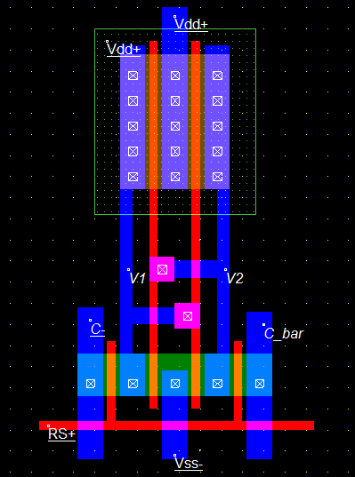

Simulation Results:

Conclusion:

